**Skill Test**

***Time Limit 60 minutes.***

Note: Manage your time carefully.

Instructions:

* Start by saving this document using your name using the Save As option.
* You can work on the same document after you have changed the name of the document.
* Do not forget to save.

1. What do you understand by brand? Explain in 100-200 words.
2. Given that you have gone through the website [www.zizira.com](http://www.zizira.com) and our social platforms, your answer to the below question should align to the Zizira brand.

Caption any **one** of the following images for a post on Facebook, Instagram and Twitter remembering that all platforms require different treatment; using the right description and hashtags (#) that will get people to engage with likes, shares, and comments. (Word limit 100-200)

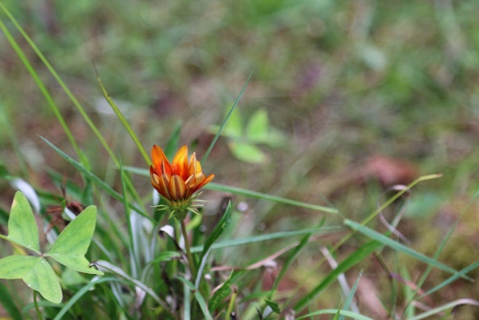

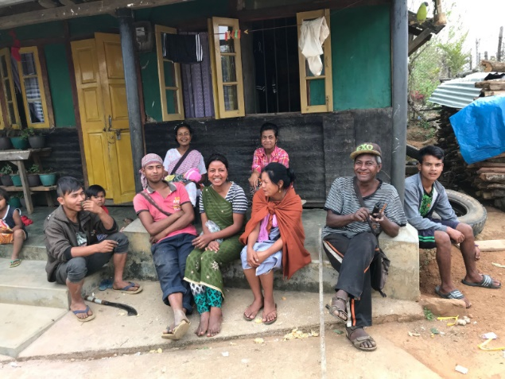

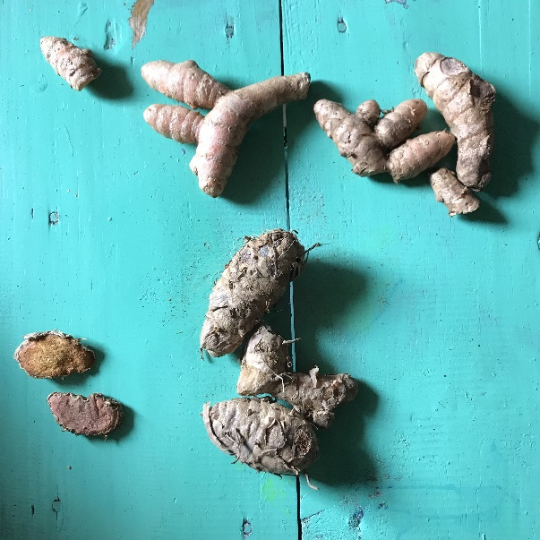

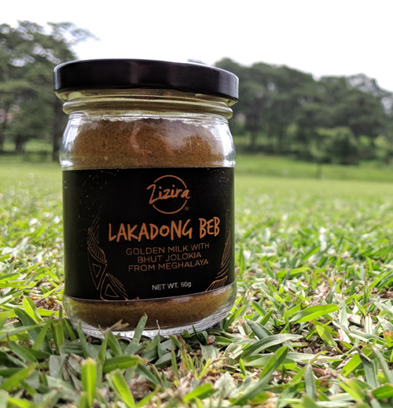

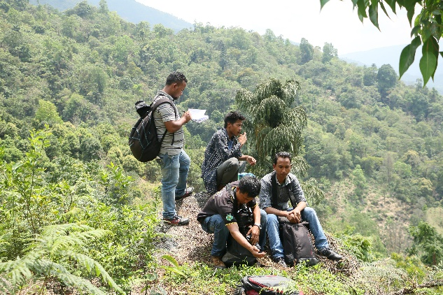

1. From your observation, of any of your favorite brand, what determines its success? Explain in 100 - 200 words.
2. What is the market trend that you see in India? What will keep a company strong and resilient from competition? Explain in 100-200 words.
3. Write a script for a 1-minute video on ‘how to use/prepare Ing Makhir Fit Tea’. Product description provide: <https://www.zizira.com/products/ing-makhir-fit-tea-meghalaya>

**All the best**